ĐỀ KIỂM TRA CUỐI KÌ 1 LỚP 5 – ĐỀ SỐ 3
A. LISTENING
Listen and number
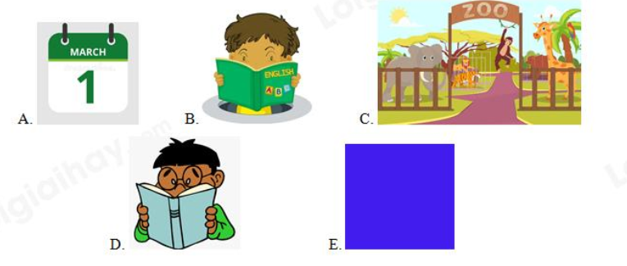

B. VOCABULARY & GRAMMAR
I. Odd one out
1. A. sang B. washed C. watched D. played
2. A. reading B. morning C. speaking D. cleaning
3. A. Sunday B. November C. December D. February
4. A. twenty B. tenth C. thirty D. forty-two
5. A. Chinese B. Australian C. England D. Japanese
II. Find ONE mistake in each sentence and correct it
1. She don’t like IT and Music.
______________________________________________________________________
2. What book are Rei reading?
______________________________________________________________________
3. What do you see at the zoo last week?
______________________________________________________________________
4. He is going to visits Da Nang city next week.
______________________________________________________________________
5. How many lesson do you have on Friday?
______________________________________________________________________

III. Give the correct form ò the verbs in the brackets
1. Nam (listen) _________ to radio every day .
2. _________ he (have) _________ a lot of friends?
3. His dad (take) _________ him to see a doctor last week.
4. She often (chat) _________ with her sister.
5. Yesterday, I (go) _________ to bed early .
IV. Read the following text and choose the best answer (A, B, C or D)
Next Wednesday (1) __________ our school Sport Day. The event will take place in the school field from the morning till 6 o’clock in the evening. All of my classmates (2) ________ for this day. I think it will be very interesting. Half of my class will take part (3) ________ the Sport Day. Jack and Tony are going to play basketball. They are two of the best (4) ________ in the team. Anna is going to play volleyball and Bella is going to play tennis. I am going to swim. Swimming is my (5) ________ sport. All of us are very excited about the big day.
1.A. will B. is C. will be D. was
2.A. is preparing B. are preparing C. prepares D. prepared
3.A. in B. on C. at D. of
4.A. player B. a player C. players D. the player
5.A. favorite B. like C. brave D. main
V. Rearrange the words to make correct sentences
1. table/ play/ Linda/ is/ tennis/ to/ going.
____________________________________________________________________.
2. Day/ will/ be/ weekend/ Sport/ this/ ./
____________________________________________________________________.
3. often/ do/ how/ have/ you/ your/ lesson/ favorite/ ?/
____________________________________________________________________?
4. do / tomorrow / what / will / you ?
____________________________________________________________________.
5. did / on / go / where / last holiday / you ?
____________________________________________________________________?
ĐÁP ÁN
A. LISTENING
A - 5 B - 2 C - 1 D - 3 E - 4

B. VOCABULARY & GRAMMAR
I. Odd one out
1. A 2. B 3. A 4. B 5. C

II. Find ONE mistake in each sentence and correct it
1. don’t => doesn’t
2. are => is
3. do => did
4. visits => visit
5. lesson => lessons
III. Give the correct form ò the verbs in the brackets
1. listen 2. Does - have 3. took 4. chats 5. went

IV. Read the following text and choose the best answer (A, B, C or D)
1. C 2. B 3. A 4. C 5. A

V. Rearrange the words to make correct sentences
1. Linda is going to play table tennis.
2. This weekend will be Sport Day.
3. How often do you have you favorite lesson?
4. What will you do tomorrow?
5. Where did you go on last holiday?

